**Practical No. 14: Develop program for implementation of Vectors in Java.**

**Practical Significance:**

Vector implementation a dynamic array. Vector hold different number of objects. Students will able to use Vectors in the program efficiently.

**Relevant Course Outcome:**

Develop programs using Object Oriented methodology in Java.

**Practical Outcome:**

|  |  |  |  |
| --- | --- | --- | --- |
|  | **Sr.**  **No.** | **Syntax** | **Task Performed** |
| 1. | void add Element(Object ob) | Adds the specified component to the end of this vector increasing its size by one |
| 2. | int capacity() | Returns the current capacity of this vector |
| 3. | boolean contains(Object elem) | Tests if the specified object is a component in this vector. |
| 4. | void clear() | Removes all the element form this vector |
| 5. | Object elementAt(int index) | Returns the component at specified index |
| 6. | Enumeration elements() | Returns enumeration of components of this vector |
| 7. | Object firstElement() | Returns first component of this vector |
| 8. | Object lastElement() | Returns last component of this vector |
| 9. | int indexOf(Object elem) | Searches for the first occurrence of given argument |
| 10. | void insetElementAt(Object obj, int index) | Inserts specified object as a component at the specified index position |
| 11. | void removeElementAt(int index) | Removes the element at specified position in the vector |
| 12. | boolean removeElement(Object obj) | Removes first occurrence of the argument form the vector |

Develop program for implementation of Vectors in Java.

|  |  |  |  |
| --- | --- | --- | --- |
|  | 13. | Int size() | Returns number of component in the vector |
| 14. | void copyInto(Object[] array) | Copies the components of vector into specified array. |

**Program Code**

import java.util.*;

public class Vector_Example

{

public static void main(String[] args)

{

Vector vec = new Vector(); vec.add(“Government ");

vec.add("Polytechnic");

vec.add("Solapur");

System.out.println("---------------------Elements in Vector are as follows-------------------");

System.out.println(vec);

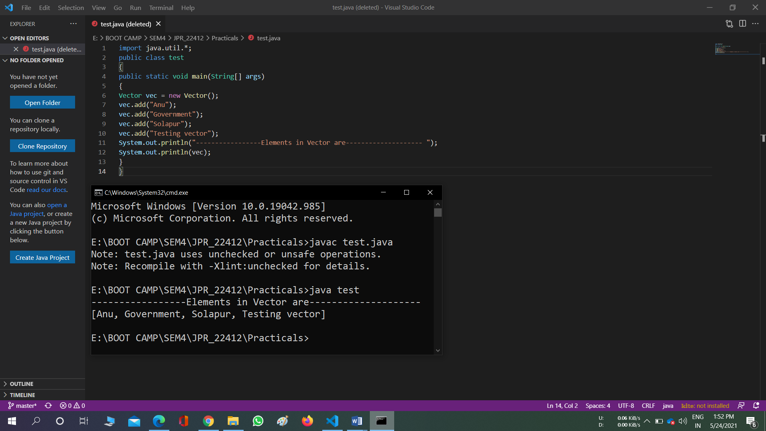

**Practical Related Questions:**

1. **State difference between size() and capacity() method of Vector class.**

The difference between capacity() and size() in java. util. Vector is that the size() is the number of elements which is currently hold and capacity() is the number of element which can maximum hold. A Vector is a dynamically grow able data structure, and it would reallocate its backing array as necessary.

1. **Differentiate between addElement() and insertElementAt() methods of Vector class.**

addElement() method is used to add an object at the end of vector and increase the size of vector by one.

insetElementAt() method is used to insert a particular element at specified index of the vector.

1. **Difference Between Array & Vector**

1. Array cant grow and shrink dynamically.

Vector can grow and shrink dynamically.

1. Array is a static list of primitive data types.

Vector can hold dynamic list of objects or primitive data types.

1. Array class is found in java.lang (default) package.

Vector class is found in java.util package.

1. Array can store elements of same data type.

Vector can store elements of different data types.

1. For accessing elements of an array no special methods are available as it is nor a class, but a derived type.

Vector class provides different methods for accessing and managing vector elements.

6. Syntax:

Datatype array_name[] = new datatype[size] Syntax:

Vector object_name = new Vector()

1)

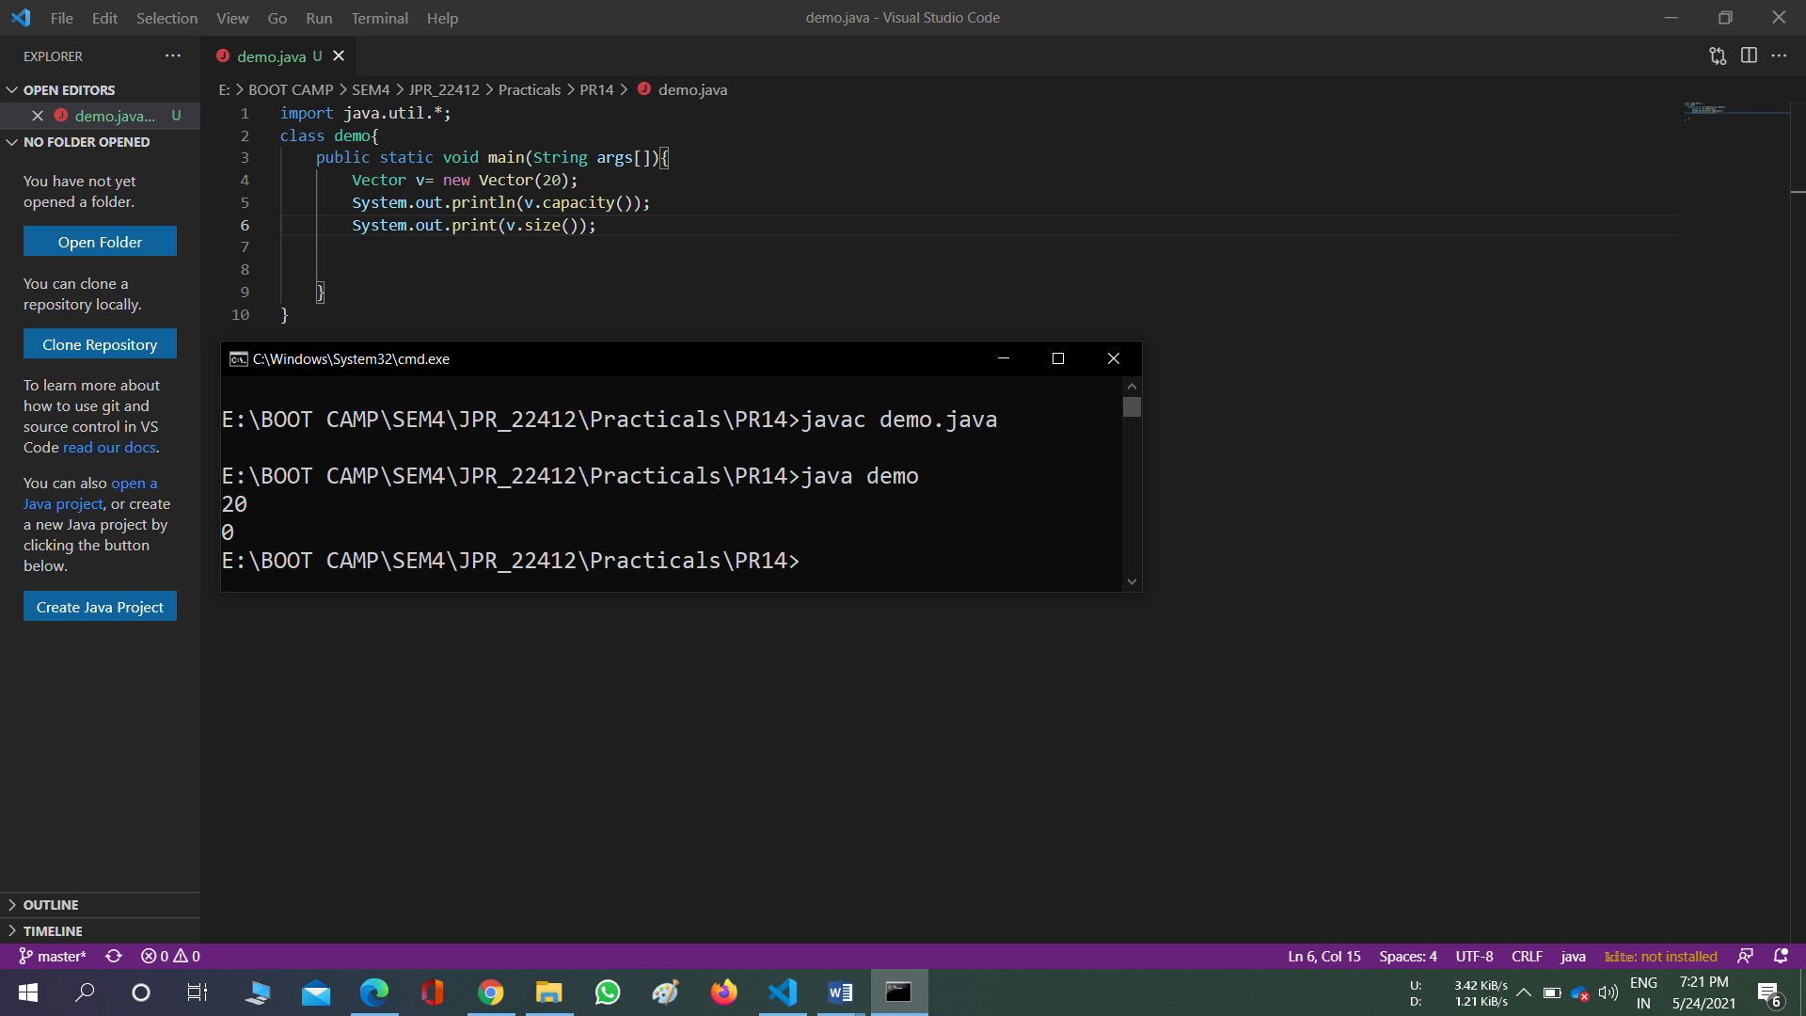

2)

import java.util.*; class test2

{

public static void main(String[] agrs)

{

Vector v = new Vector();

System.out.println(v.capacity());

 System.out.println(v.size());

  v.add("Hello");

 System.out.println(v);

  v.add("Java");

  System.out.println(v);

   v.addElement("World");

    System.out.println(v);

v.clear();

System.out.println(v);

v.add("Hello");

 System.out.println(v);

 v.add("Java");

  System.out.println(v);

 v.addElement("World");

  System.out.println(v);

 v.contains("Hello");

 System.out.println(v);

 v.elementAt(1);

 System.out.println(v);

 v.indexOf("Java");

  System.out.println(v);

  v.firstElement();

   System.out.println(v);

  v.lastElement();

   System.out.println(v);

v.insertElementAt("Program",1);

 System.out.println(v);

 v.removeElement("Program");

  System.out.println(v);

  v.removeElementAt(1);

   System.out.println(v);

    v.removeAll(v);

     System.out.println(v);

}

}

